UNIT 4
Advanced Video Editing
Using Video Effects in iMovie - Working with Still Photos and Graphics- Previewing video - Exporting Movies for the Online World - Exporting Digital Video to Tape - Recording CDs and DVDs – Tools for digital video production

iMovie is a user-friendly video editing software developed by Apple for macOS and iOS. It allows users to create and edit videos with various features, making it accessible for beginners and efficient for more experienced users.
Using Video Effects in iMovie
iMovie offers a variety of video effects that can enhance your projects. Here are some of the key video effects and tools you can use in iMovie:
1. Video Filters
You can apply preset filters to give your video a unique style. To add a filter:
Select a video clip in your timeline.
Click the Filters button (looks like three overlapping circles) above the viewer.
2. Transitions
iMovie provides a range of transition effects to seamlessly connect clips.
Go to the Transitions tab above the timeline.
Drag and drop transitions like Fade, Slide, or Wipe between two clips.
3. Green/Blue Screen (Chroma Key)
This effect allows you to replace the background in your video:
Add your green screen footage to the timeline.
Drag and drop the video or image to use as a background above the green screen clip.
Click the Video Overlay Settings button, then choose Green/Blue Screen to blend the clips.
4. Slow Motion/Speed Up
To adjust the speed of a clip:
Select your video clip in the timeline.
Click the Speed button (looks like a speedometer) above the viewer.
Choose to slow down or speed up your clip. You can also freeze a frame for dramatic pauses.
5. Picture-in-Picture (PIP)
This effect places a smaller video clip in the corner of your main video:
Drag and drop the secondary video clip above the main clip in the timeline.
Click the Video Overlay Settings button, and select Picture-in-Picture.
6. Split Screen
You can display two video clips side by side:
Drag two video clips to the timeline.
Click the Video Overlay Settings button and choose Split Screen.
7. Stabilization
For shaky footage, you can use stabilization:
Select your clip and click the Stabilization button (camera icon).
Enable Stabilize Shaky Video to smooth out motion.
8. Color Correction
To adjust the brightness, contrast, and saturation:
Select a video clip and click the Color Correction button (palette icon).
Use sliders to adjust the look of the clip.
9. Ken Burns Effect (Pan and Zoom)
You can add a pan or zoom effect to still images or video:
Select the clip and click the Crop button.
Choose the Ken Burns option to set start and end points for the motion.

WORKING WITH STILL PHOTOS
1. Import Photos and Graphics
Open iMovie and create a new project.
Click on "Import Media" to bring in your still photos or graphics (JPEG, PNG, etc.).
Drag them into your timeline.
2. Add Photos to the Timeline
Once imported, drag your photos or graphics from the media library directly into the timeline where you want them to appear.
3. Adjust Duration
By default, iMovie sets a still image to last for a few seconds. Adjust the duration by clicking on the edge of the image in the timeline and dragging it to make it shorter or longer.
4. Apply Ken Burns Effect (Pan & Zoom)
iMovie uses the Ken Burns effect to add motion to still images
The Ken Burns effect adds motion to still images:
Select a Photo: Click on the photo in the timeline.
Enable Ken Burns: In the viewer, click the Crop button, then select Ken Burns.
Adjust the Start and End Frames: Use the boxes to frame the start and end positions of the photo. This creates a zooming or panning effect.
Step 5: Enhance Photos with Effects
Select a Photo: Click on the photo in the timeline.
Open Filters: Click the Filters button above the viewer to apply visual effects.
Choose an Effect: Browse and select a filter, then click Apply.
Step 7: Add Titles (if needed)
Open Titles: Click the Titles button in the toolbar.
Select a Title Style: Drag your chosen title style to the timeline above the photo.
Edit Text: Click on the title in the viewer to customize the text.
Step 8: Review and Adjust
Playback: Watch your project in the viewer to see how the photos and effects come together.
Make Adjustments: Tweak durations, effects, or transitions as needed.
Step 9: Export Your Project
Share Your Movie: Once satisfied, click the Share button (the box with an arrow).
Select Export Settings: Choose your desired resolution and format, then follow the prompts to save your project.
How to Preview a Video in iMovie
Play from Timeline:
- Click on any point in the timeline where your video clips are located.
- Press the Spacebar or click the Play button (►) just below the viewer (top-right panel).
- Your video will play in the Viewer window.

Preview Specific Clips:
- To preview a particular clip, click on the clip in the timeline.
Press the Spacebar or click the Play button to watch just that portion
Full-Screen Preview:
- For a full-screen preview, click on the Full-Screen button in the bottom-right corner of the Viewer window (two diagonal arrows).
- Press Esc to exit full-screen mode and return to editing.
Preview Effects & Transitions:
- As you apply effects or transitions, preview them in real-time by positioning the playhead before the transition or effect and pressing Play.
Loop Playback:
- If you want to repeatedly preview a certain section, drag the playhead over the section you want to loop, right-click, and select Play Selection.
Exporting Movies for the Online World
Step 1: Complete Your Project
- Finalize Edits: Make sure you’ve finished all edits, including effects, transitions, and titles.
Step 2: Open the Share Menu
- Click the Share Button: In the top-right corner of the iMovie interface, click the Share button (it looks like a box with an arrow).
Step 3: Choose Export Options
- Select "File": This option lets you export your movie to a file on your computer.
- Choose "YouTube" or "Vimeo": If you want to upload directly to a platform, select the corresponding option.
Step 4: Set Export Settings
- File Format: If you selected "File," choose the following settings:
  - Resolution: Options typically include 4K, 1080p, and 720p. Choose based on your needs.
  - Quality: Select from Low, Medium, High, or Best (ProRes).
  - Compress: Choose either "Better Quality" or "Faster Encoding."
- For YouTube/Vimeo:
  - Sign in to your account if prompted.
  - Fill in details like title, description, and tags.
Step 5: Export the Movie
- Click "Next": After setting your preferences, click Next.
- Name Your File: Enter a name and choose a location to save the file.
- Click "Save": iMovie will begin exporting your movie. The time taken will depend on the length and complexity of the project.
Step 6: Uploading to Online Platforms
- Manual Upload: If you exported the movie file, go to your chosen platform (YouTube, Vimeo, etc.), and upload the file following the platform’s instructions.
- Direct Upload: If you used the direct option, iMovie will handle the upload after exporting.

EXPORTING DIGITAL VIDEO TO TAPE:

Selecting Tape Format:
Determine the analog videotape format you'll be using for exporting the digital video. Common formats include VHS, Betamax, Hi8, or MiniDV.

Preparing Playback Device:
Connect a compatible tape playback device to your computer or digital storage device. This could be a VCR, camcorder, or other analog tape deck equipped with video input capabilities.

Connecting Devices:
Use the appropriate cables to connect the playback device to your computer or digital storage device. This may involve composite, S-video, or FireWire cables depending on the connection options available.

Preparing Video Files:
Ensure that the digital video files you wish to export are stored on your computer or digital storage device. These files should be in a compatible format for playback and recording onto analog tape.

Opening Video Editing Software:
Launch video editing software on your computer. This could be the same software used for editing the digital video files or a dedicated video export application.

Importing Video Files:
Import the digital video files into the video editing software. This may involve dragging and dropping files into the editing timeline or using a specific import function within the software.

Setting Export Settings
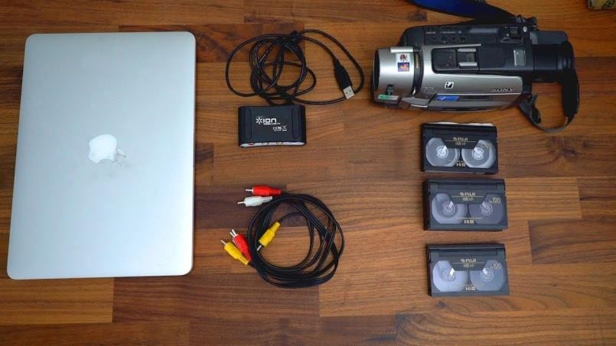
Configure the export settings within the video editing software to match the specifications of the analog tape format you'll be using. This includes selecting the appropriate resolution, frame rate, and compression settings.

Connecting Playback Device:
Connect the playback device (VCR, camcorder, etc.) to the output port on your computer or digital storage device. Ensure that the connection is secure and properly configured.

Starting Export Process:
Begin the export process within the video editing software. This may involve selecting the "Export" or
"Render" option from the menu and choosing the output format and destination.

Recording onto Tape:
Once the export process is initiated, start playback on the connected tape playback device. The digital video files will be transferred from your computer or digital storage device onto the analog tape in real-time.
Monitor the export process to ensure that it progresses smoothly and without errors. Pause or stop recording if any issues arise.

Finalizing Export:
Once the export process is complete, stop playback on the tape playback device and finalize the recording. This may involve finalizing the tape on the device or ensuring that the recording is saved correctly.

Testing Playback:
Test the recorded tape on a compatible playback device to ensure that the digital video files were successfully transferred and recorded onto the analog tape. Check for any playback issues or errors.
By following these steps, you can effectively export digital video to tape for playback on analog videotape formats. Adjustments and additional steps may be required depending on the specific equipment and software used for the export process.

COMPACT DISK
A CD, or Compact Disc, is a digital optical disc storage format used for storing and playing back digital data, including audio, video, and other types of multimedia content. It was introduced in the early 1980s and quickly became a popular medium for distributing music albums, software applications, video games, and other digital content.
Here are some key characteristics and features of CDs:
Physical Format: CDs are typically 12 centimeters (4.75 inches) in diameter and are made of polycarbonate plastic. The data is encoded onto the reflective surface of the disc using microscopic pits and lands.
Storage Capacity: A standard CD can store up to 700 megabytes (MB) of data, which is equivalent to about 80 minutes of uncompressed audio or approximately 60 minutes of MPEG-1 compressed video.
Audio CDs: The most common type of CD is the audio CD, which contains digital audio recordings in a standardized format. These CDs can be played on CD players, CD-ROM drives, and other compatible devices.
Data CDs: In addition to audio, CDs can also store data files such as documents, images, and software programs. These are often referred to as data CDs and can be read by computers and other devices with CD-ROM drives.
Writable CDs: Writable CDs, such as CD-R (CD-Recordable) and CD-RW (CD-Rewritable), allow users to record (write) data onto the disc once or multiple times, respectively. These discs can be burned using a CD burner or recorder.
Playback Compatibility: CDs are compatible with a wide range of devices, including CD players, CD-ROM drives, DVD players (for audio CDs), computers, game consoles, and car stereo systems.
Durability: CDs are relatively durable and resistant to scratches and surface damage, although they can be susceptible to warping and deterioration over time if not properly handled and stored.
Standardization: CDs adhere to various industry standards, including the Red Book standard for audio CDs, the Yellow Book standard for data CDs, and the Rainbow Books for writable and rewritable CD formats.

VDC
A VCD, or Video CD, is a digital optical disc format primarily used for storing and playing back video content. It was developed in the early 1990s as an extension of the CD standard and provides a lower-cost alternative to DVDs for distributing video content.
Here are some key characteristics and features of VCDs:
Physical Format: Similar to audio CDs, VCDs are 12 centimeters (4.75 inches) in diameter and made of polycarbonate plastic. The data is encoded onto the reflective surface of the disc using microscopic pits and lands.
Storage Capacity: A standard VCD can store up to 80 minutes of video content using MPEG-1 compression. This typically results in slightly lower video quality compared to DVDs, but VCDs remain popular in regions where DVD players may not be as prevalent.
Video Compression: VCDs use the MPEG-1 video compression standard to encode video content. This compression method allows for relatively small file sizes while maintaining reasonable video quality.
Playback Compatibility: VCDs can be played on most DVD players, as well as dedicated VCD players and certain CD-ROM drives equipped with MPEG-1 video decoding capabilities. Many standalone DVD players are backward- compatible with VCDs, allowing users to play VCDs alongside DVDs.
Menu and Chapter Support: VCDs can include basic menu navigation and chapter support, allowing users to navigate between different sections or chapters of the video content. However, the menu functionality on VCDs is typically less sophisticated than that of DVDs.
Writable VCDs: Similar to writable CDs, VCDs can be created using CD-R (CD-Recordable) discs. Users can use CD burning software to create VCDs from digital video files, which can then be played back on compatible devices.
Region-Free Playback: Unlike DVDs, which often have region coding to restrict playback in specific geographic regions, VCDs are typically region-free. This means that VCDs can be played on any compatible player regardless of the region where they were purchased or created.

RECORDING TO CDS AND VCDS:

Selecting CD Burning Software:
Choose CD burning software that supports the creation of Video CDs (VCDs) or data CDs containing digital video files. Examples of such software include Nero Burning ROM, ImgBurn, or Windows Media Player.

Preparing Video Files:
Ensure that the digital video files you wish to record onto the CD are stored on your computer. These files should be in a compatible format for burning onto CDs, such as MPEG-1 or MPEG-2 for VCDs.

Opening CD Burning Software:
Launch the CD burning software on your computer. This could be a standalone CD burning program or integrated into other multimedia software.

Selecting CD Type:
Choose the type of CD you want to create. For VCDs, select the option for creating a Video CD. For data CDs containing video files, choose the option for burning data discs.

Importing Video Files:
Import the digital video files into the CD burning software. This may involve dragging and dropping files into the software interface or using a specific import function.

Arranging Files:
Arrange the video files in the desired order within the CD burning software. This determines the playback sequence of the videos once the CD is inserted into a compatible player.

Adding Menus and Chapters (Optional):
Some CD burning software allows you to create menus and chapters for VCDs. This provides a navigational interface for viewers to select specific videos or chapters to play.

Setting Burn Options:
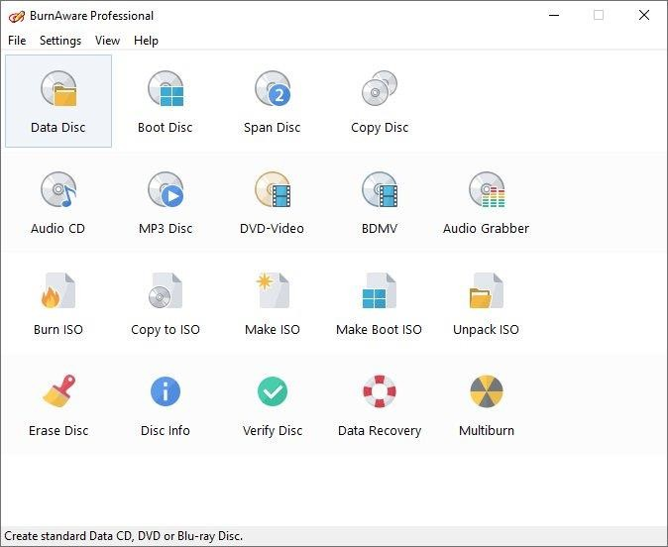
Configure the burn options within the CD burning software. This includes selecting the burning speed, disc format (e.g., VCD or data CD), and other preferences.

Inserting Blank Disc:
Insert a blank writable CD into your computer's CD/DVD drive. Make sure the disc is compatible with the chosen CD format (e.g., CD-R for VCDs).

Starting Burn Process:
Initiate the burn process within the CD burning software. This may involve clicking a "Burn" or "Start" button to
begin writing the digital video files onto the CD.

Monitoring Burn Progress:
Monitor the burn process to ensure that it progresses smoothly and without errors. Some CD burning software provides progress indicators or status bars to track the burning progress.

Finalizing Disc (Optional):
If creating a VCD with menus and chapters, finalize the disc within the CD burning software once the burn process is complete. This ensures that the disc structure is correctly written and can be played back on compatible players.

Testing Playback:
Test the recorded CD or VCD on a compatible CD or DVD player to ensure that the digital video files were successfully burned onto the disc. Check for any playback issues or errors.
By following these steps, you can effectively record digital video files onto CDs and VCDs for playback on compatible CD or DVD players. Adjustments and additional steps may be required depending on the specific CD burning software and disc format used for recording.

Essential tools for digital video production:
- Cameras
DSLRs and Mirrorless Cameras: Popular for high-quality video (e.g., Canon, Nikon, Sony).
Camcorders: Designed specifically for video recording (e.g., Panasonic, Canon).
Smartphones: Many modern smartphones offer excellent video capabilities.
- Tripods and Stabilizers
Tripods: Essential for stable shots. Look for adjustable tripods that suit your camera.
Gimbals and Steadicams: For smooth, stable moving shots.
- Audio Equipment
Microphones: Lavalier (clip-on), shotgun, and handheld microphones for various recording needs.
Audio Recorders: External recorders (e.g., Zoom H4n) for better audio quality.
Headphones: For monitoring audio while recording.
- Lighting
LED Lights: Versatile and energy-efficient options for various shooting environments.
Softboxes and Diffusers: To soften and diffuse light for a more flattering look.
Reflectors: To bounce light and fill shadows.
- Editing Software
iMovie: User-friendly software for beginners.
Final Cut Pro: Advanced editing software for Mac users.
Adobe Premiere Pro: Industry-standard editing software with extensive features.
DaVinci Resolve: Great for color correction and advanced editing.
- Graphics and Animation
Adobe After Effects: For creating motion graphics and visual effects.
Apple Motion: For motion graphics and visual effects for Final Cut Pro users.
- Storage Solutions
External Hard Drives: For backing up footage and projects.
Cloud Storage: Services like Google Drive or Dropbox for file sharing and collaboration.
- Distribution Platforms
YouTube: For sharing videos with a wide audience.
Vimeo: For professional video sharing with privacy options.
Social Media: Platforms like Instagram, Facebook, and TikTok for reaching audiences.

*****Refer the following topics on your Notebook*****
- Evolution of Final cut pro editing tool.
- Animation effects created by Final cut pro editing tool.
- Comparison between Final cut pro vs Adobe premiere pro for editing.
- Tools used in final cut pro software.
- Features, pros, and cons of final cut pro software.
- Steps to use final cut pro for video editing.

